Requirements and Analysis Document for NNN

Version: 0.5

Date: Monday, March 27, 2017

Author: Felix Nordén

This version overrides all previous versions.

# Introduction

Background explaining why this application is needed (besides mandatory in course). What's the problem addressed (use imagination)? What will it do? Who will benefit/use from this application? In what situation will the application be used? Defining the application. General characteristics of application.

Today, where each individual gets more and more involved, the 24 hours a day we have at hand feels smaller and smaller. Being able to fit everything of interest into our day becomes more difficult and the time we can allocate is becoming smaller by the day.

Sleep deprivation has become a necessity and is a merit when applying for any form of profession. In conjunction, the demand on tools for planning has never been higher. They need to be fast, effective, and most importantly, they must have a small learning curve. However, amidst all of these time pressured schedules, the joy of life can be somewhat forgotten. Therefore, we in project group “Coffee Break” decided to create something that would fill the needs for efficient planning, and also give the user a reward to make planning a bit more fun.

## 1.1 Definitions, acronyms and abbreviations

Create word list to avoid confusion.

Todo-list – A list of different tasks that the user wishes to get done.

Task – The simple item that the user can add to his/her todo-list

List task – A more complex version of a task, which creates both a category with the List task name and also contains a list of different tasks.

Time Category – The category which tasks can be sorted into which involve a certain timeframe

Label Category – Custom categories that the user can create through either adding custom labels/tags onto their task during creation, or through setting up static categories which are always visible.

Test-driven development – Before any new code is written for the application, a test for the specified component will be make using the different specifications for the component as guidelines. This will lessen the number of bugs in the end product.

MVC – “Model, View, Controller”, a design model used in the most applications/programs today. The Model is the database which handles all of the logic and calculations. The View is the what is actually shown to the user, and the Controller handles the interaction between the user and the Model.

Object Oriented implementation – A certain form of programming paradigm, where the coding is divided into different objects and classes. This is to break up the different tasks into smaller, more manageable parts and then tackling the problem by creating one “puzzle piece” at a time.

# 2. Requirements

## 2.1 User interface

Sketches, drawings and explanations of the application user interface (possible navigation).

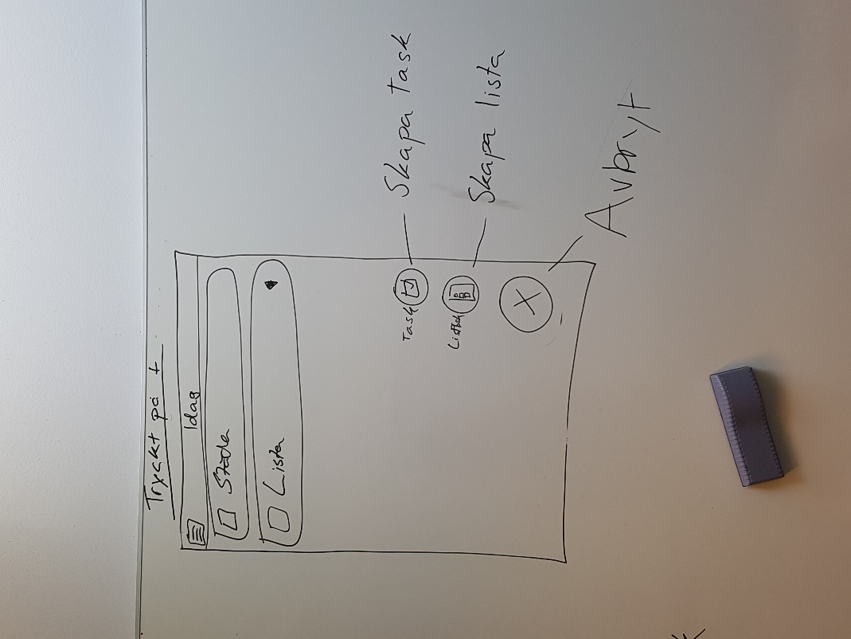

Sketch 2 - Home Screen view of the application, where the user has pushed the "Add item" button in the lower, right corner and now has the choice to create either a Task or a List

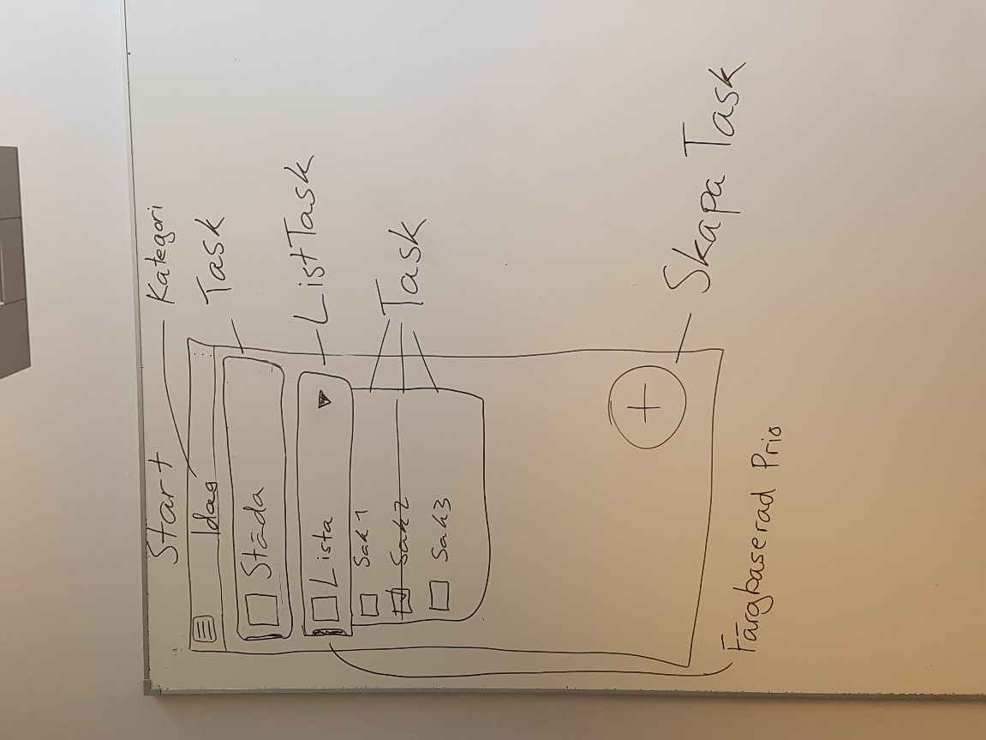

Sketch 1 - Start Screen for the Application, with the different features marked out

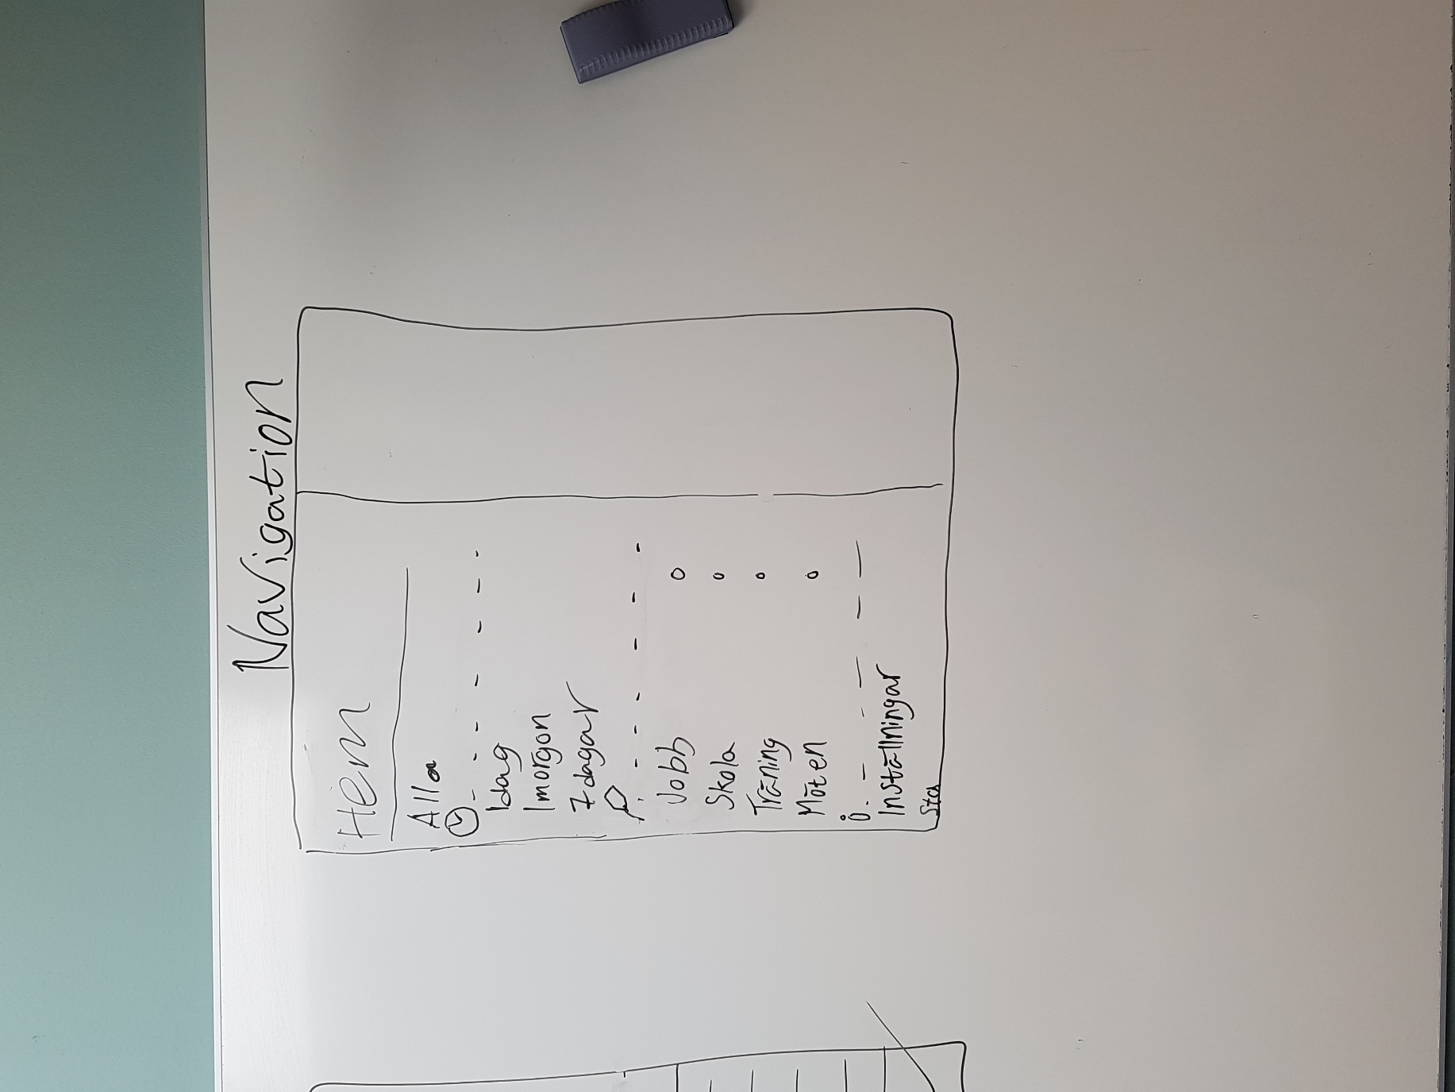

Sketch 4 - Description for the Navigation Drawer, which is accessed by pushing the upper left button, or sliding from the left side of the screen

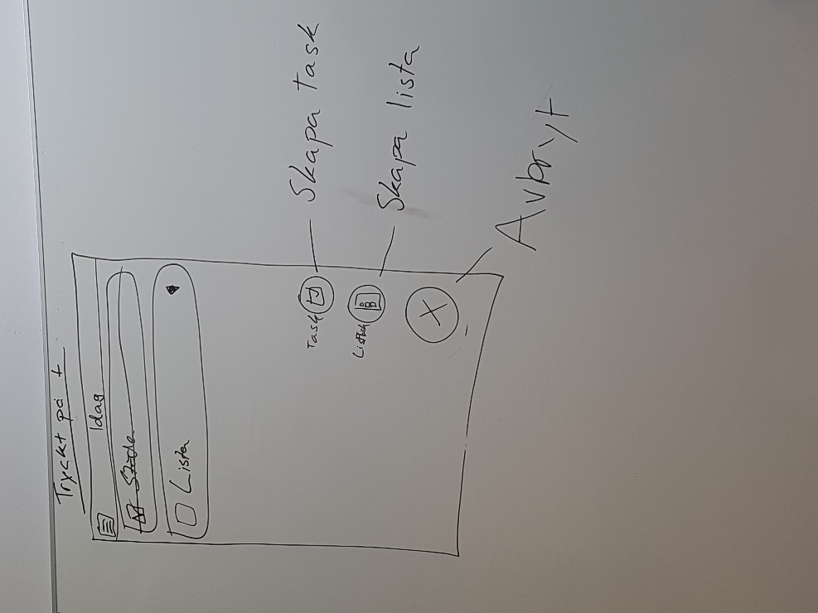

Sketch 3 - Same Home Screen view, but now the user has checked off a Task, where the system strikes through the task name and adds a checkmark in the checkbox

Sketch 5 - View of the creation of a Task, where the user types in a name for the Task and then clicks the checkmark on the keyboard to finish the creation

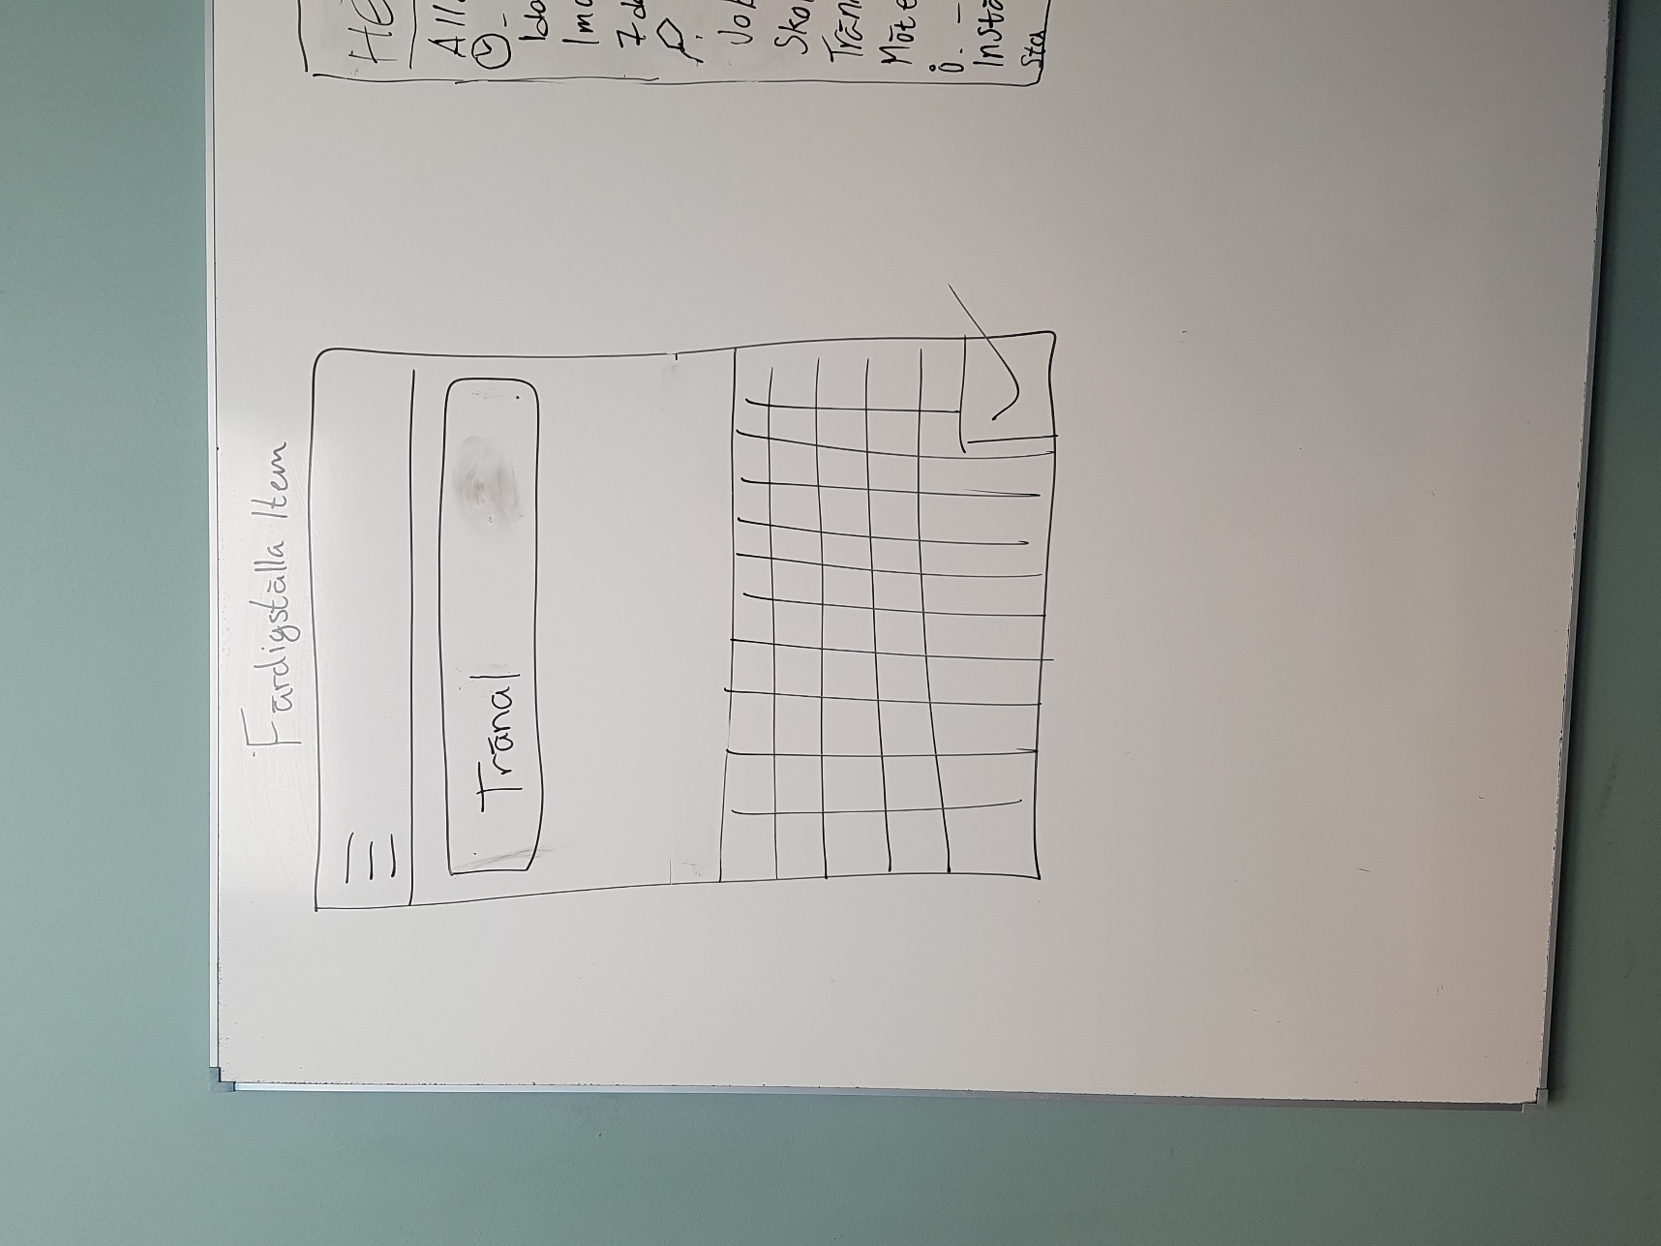

## 2.2 Functional requirements

What will the user be able to do ? Write a list of use case names (id’s) in the language of the customer. The specific flows for each use case is recorded below. Specify a use cases in priority order.

#### First Priority

* Create a new task in the form of
  + General Task
  + List Task
* Check off a task
* Filter the list to a certain category

#### Second Priority

* Update a task’s configuration
* Sort task in another order
  + Priority level
  + Chronological order
  + Alphabetical order
* Update/clean up list of done tasks
* Delete a task
* Create new filters/categories through:
  + Task creation
  + Static category creation

#### Third priority

* Change settings
* Check for help
* (Check achievements)
* (Use Advanced tools when creating Items)
  + Set tags for time, priority, category and possibly position

## 2.3 Non-functional requirements

Any special considerations ​besides functionality? Usability, reliability, performance,​ supportability, legal, implementation, … NOTE: ​Testability​ mandatory (must have tests)

* Main Categories
  + Time
  + Labels
* Standard Subcategories
  + ”Today”
  + ”Tomorrow”
  + ”7 days”
  + ”All”
  + ”Home”
  + ”Work”
  + ”Meetings”
* Support for different Android devices from OS ”Lollipop” and upwards
* Support for both tablets and smartphones
* Implementation through Java
  + Test-driven development
  + MVC-focused implementation model
  + Object Oriented implementation
* Usability
  + Simple introduction at first startup of application
  + Focused on simple use
  + Implemented functionality for more advanced usage in ”Creation mode” for tasks
* Entertainment
  + Make use of gamification through Achievements
  + Create interesting representations for statistics

# Use cases

An UML​ use case diagram

## 3.1 Use case listing

Use case texts (using the use case template)

# Domain model

An UML ​class diagram​.

## 4.1 Class responsibilities

Explanation of responsibilities of classes in diagram

# References